Assessment task — People and the environment: Sources
Source 1
Global map
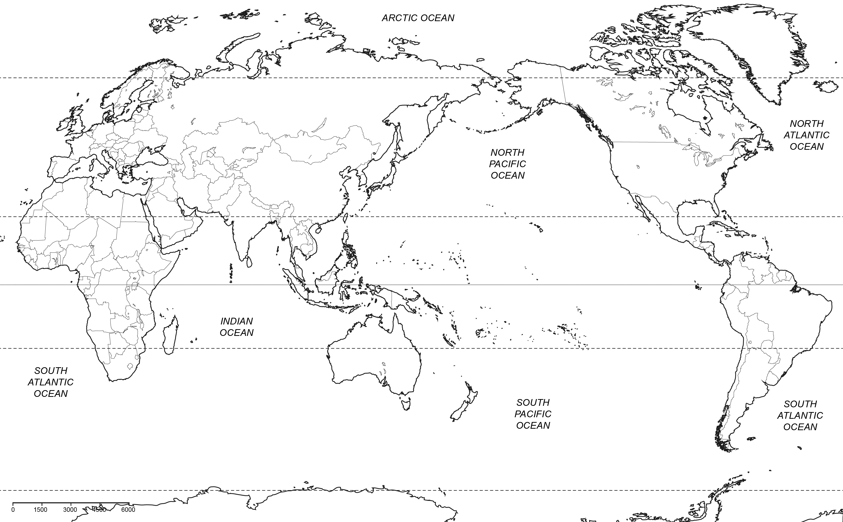

Source 2
Climate data
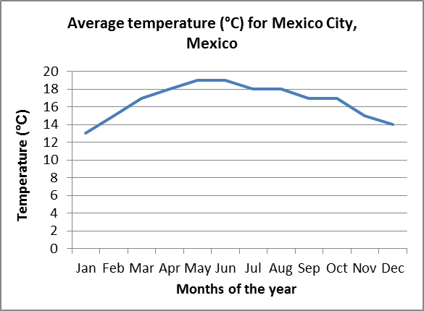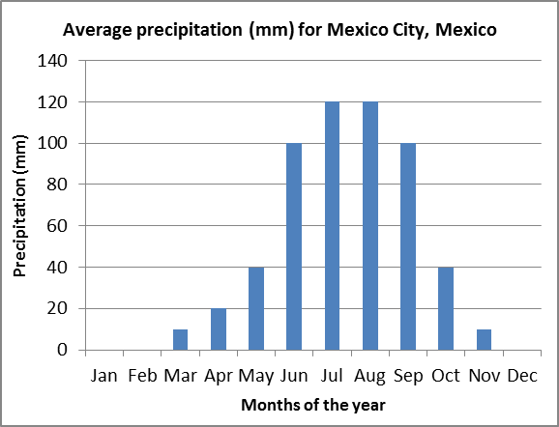
Data sourced from: weatherbase, http://www.weatherbase.com/weather/weather.php3?s=97667&cityname=Mexico-City-Mexico-City-Mexico
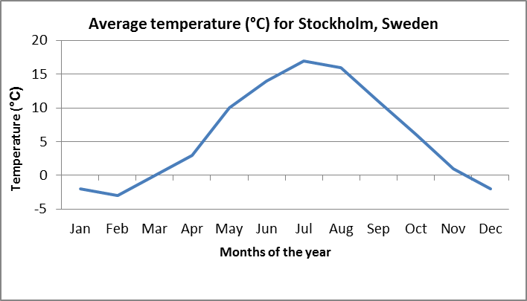 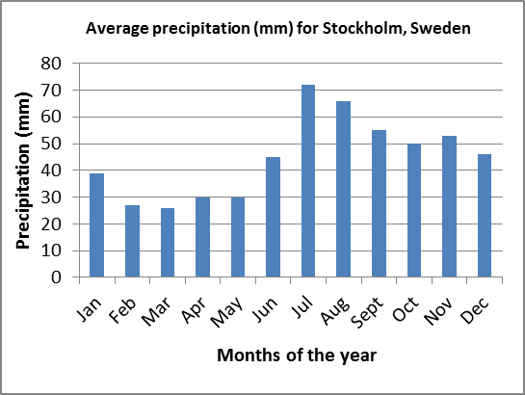
Data sourced from: weatherbase, http://www.weatherbase.com/weather/weather.php3?s=6420&cityname=Stockholm-Stockholm-Sweden

Source 3  Population density maps  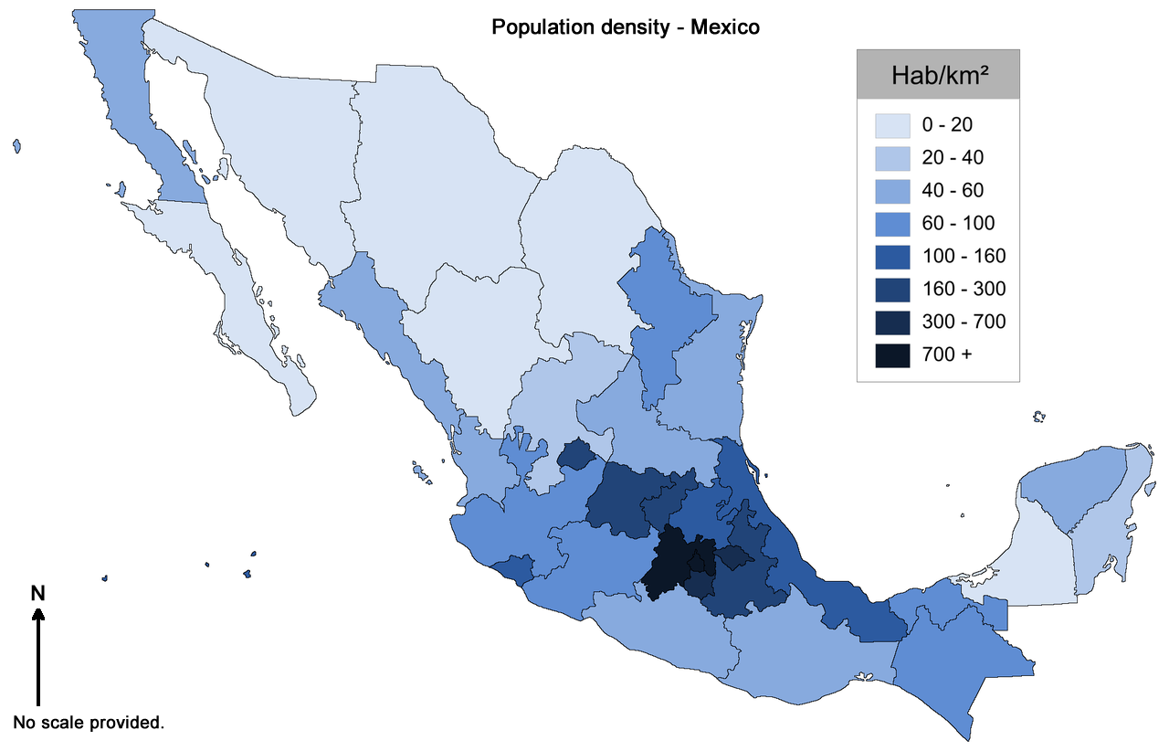  Alex RL, 2013, 2012 Density Map, https://commons.wikimedia.org/wiki/File:2012_Density_Map.png CC BY-SA 3.0 creativecommons.org/licenses/by-sa/3.0/  Vikingviolinist, 2008, Counties of Sweden 2007 with population density data. Source: Statistics Sweden,  https://commons.wikimedia.org/wiki/File:Swedishpopdensity.svg CC BY-SA 2.5 creativecommons.org/licenses/by-sa/2.5/ | 